10-DAY CAMBODIA TOUR WITH BEACH RELAXATION
Routing: SIEM REAP - PHNOM PENH – KOH RONG
Tour Style: Nature, Culture & Relaxation Tour
Tour Start: in Siemreap/ Tour End: in Koh Rong
Trip duration: 10 Days - 9 Nights

Day | Trip Summary | Meals
01 | ARRIVAL - SIEM REAP | None
02 | SIEM REAP – ANGKOR THOM – TA PROHM – ANGKOR WAT | B
03 | SIEM REAP – TONLE SAP LAKE – BANTEAY SREI – BANTEAY SAMRE | B
04 | SIEM REAP – PHNOM PENH BY PUBLIC BUS (NO GUIDE) | B
05 | PHNOM PENH – CITY TOURS | B
06 | PHNOM PENH – CITY TOURS | B
07 | KOH RONG – FREE & LEISURE | B
08 | KOH RONG – FREE & LEISURE | B
09 | KOH RONG – FREE & LEISURE | B
10 | KOH RONG – SIHANOUK VILLE - PHNOM PENH – DEPARTURE | B

TRIP DETAILS
DAY 01 ARRIVAL - SIEM REAP (-)
Upon arrival at Siem Reap airport, meets our driver and guide and transfer to hotel for check in.
(Early check-in before 14h00 is not included)
Lunch and dinner are not included
Overnight at your selected hotel in Siem Reap.

DAY 02 SIEM REAP – ANGKOR THOM – TA PROHM – ANGKOR WAT (B)
Breakfast at hotel
Rise up early to pick up the most beautiful, haunting and spiritual moment to visit magnificent Angkor Wat at dawn. This special activity is designed also to help you see “the Temple reflex on the water” when it’s much cooler and less crowded. Later on come back to the hotel for breakfast and short break.

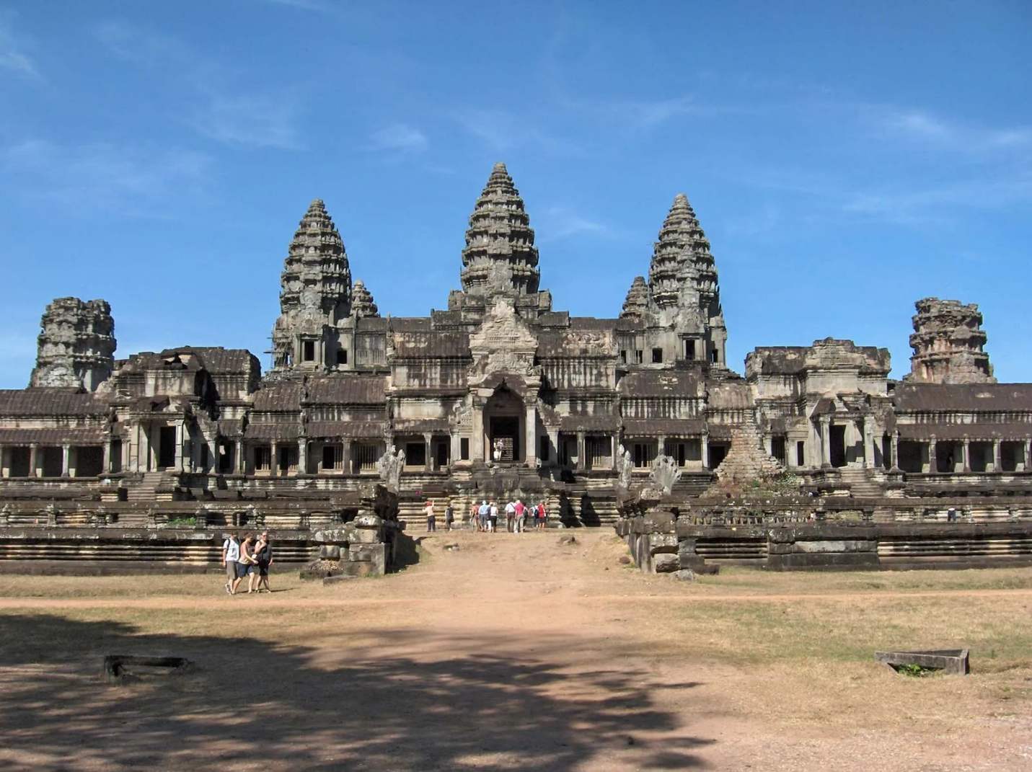
After breakfast, visit the antique capital of Angkor Thom (12 century): the South Gate with its huge statues depicting the churning of the ocean of milk, the Bayon Temple, unique for its 54 towers decorated with over 200 smiling faces of Avolokitesvara, the Phimeanakas, the Royal Enclosure, the Elephants Terrace and the Terrace of the Leper King. Then, visit Ta Prohm, one of the area’s most beautiful temples. Ta Prohm has been relatively untouched since it was discovered and retains much of its mystery.
Lunch not included
This afternoon, visit to the most famous of all the temples on the plain of Angkor: Angkor Wat. The temple complex covers 81 hectares and is comparable in size to the Imperial Palace in Beijing. Its distinctive five towers are emblazoned on the Cambodian flag and the 12th century masterpiece is considered by art historians to be the prime example of classical Khmer art and architecture.
This evening, enjoy the sunset on Bakheng Hill.
Dinner not included
Overnight at your selected hotel

DAY 03 SIEM REAP – TONLE SAP LAKE – BANTEAY SREI – BANTEAY SAMRE (B)
Breakfast at hotel
After breakfast, you will enjoy a boat ride on the Tonle Sap Lake at KAMPONG PHLUK VILLAGE. This is the largest permanent fresh-water lake in South East Asia and flows into Tonle Sap River, joining the Mekong in Phnom Penh. We will see a fishermen's "floating village" with floating schools, floating police station, etc. It is same as a big village floating on the lake, and the "village" move from place-to-place following water levels and current.
Lunch not included
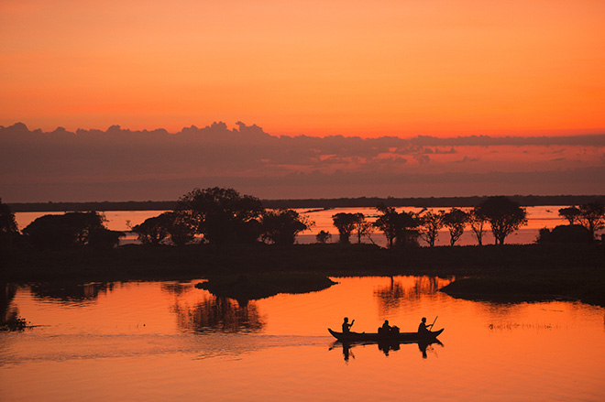

This afternoon, continue to stroll around Banteay Samre temple which was built in 12th century during Angkor period, admired by its serenity, take some beautiful photo before heading to reveal the intricately carved, beautiful red-pink sandstone temple of Banteay Srei - considered to be a Jewel of Khmer art which features elaborate decorations and its finest details. These factors have made the temple extremely popular with tourists, and have led to its being widely praised as a “precious gem”. On the way back, we will stop at Preah Dak village for a short tour, enjoying to observing the real-life of Cambodian in this area, how they make a living from the hand-made products, how to producing sugar palm and fruit itself.
Dinner not included
Overnight at your selected hotel in Siem Reap
DAY 04 SIEM REAP – PHNOM PENH BY PUBLIC BUS (NO GUIDE) (B)
Breakfast at hotel
This morning, with your driver, you will be transfer to Siem Reap to bus station for your trip to Phnom Penh.
The trip might take up to 6 or 6 hours on good conditions road.
Upon arrival at Phnom Penh bus station, meet with our driver then transfer to hotel for check-in.
Rest at your own leisure.
Lunch and dinner are not included
Overnight at your selected hotel in Phnom Penh

DAY 05 PHNOM PENH – CITY TOURS (B)
Breakfast at hotel
After breakfast, After the breakfast, head out to the Choeung Ek Memorial, where a stupa made up of some 8,000 human skulls marks the site of the infamous Killing Fields. This was the execution ground for the torture victims of TuolSleng and standing in this peaceful setting it's almost unthinkable to imagine that to date nearly 9000 corpses have been exhumed from the area. Then, continue your visit to Tuol Sleng Genocide Museum (S21 prison). This prison was a high school, and used as a prison by Pol Pot's security forces and became the largest center for detention and torture during the rule of the Khmer Rouge.
Lunch not included
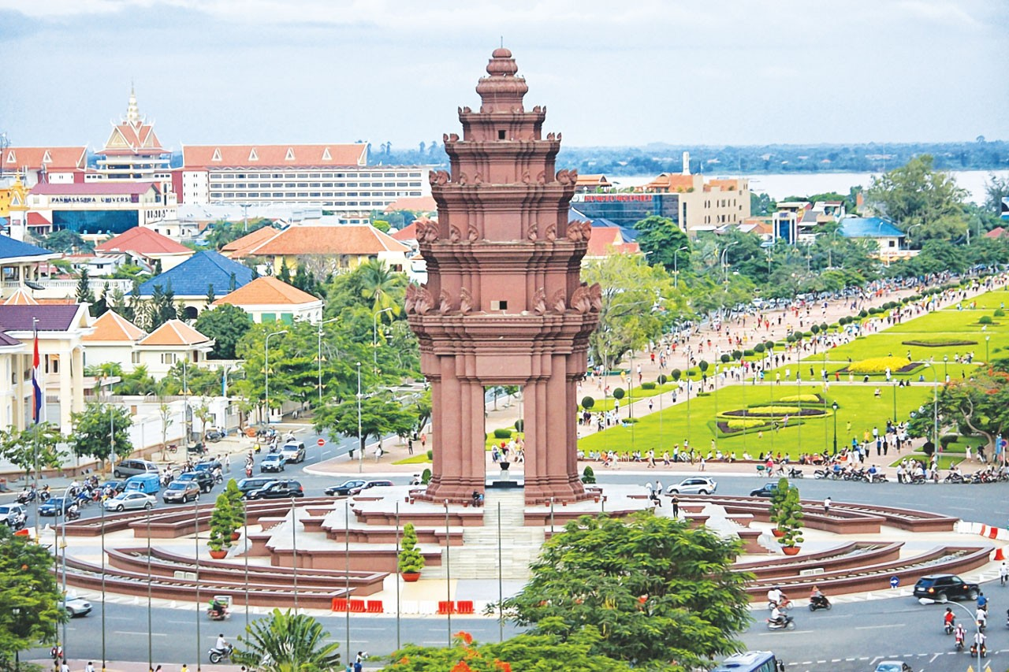
In the afternoon, visit the Royal Palace, built by King Norodom in 1866 on the site of the old town, and the Silver Pagoda, located within the grounds of the Royal Palace, the Silver Pagoda is so named because of its floor, which is made up of 5000 silver tiles. Then, continue your visit at visit to the National Museum, one of Phnom Penh's true architectural gems. The Museum is instantly recognizable with its warm red terracotta and its gracefully cured roof topped by dozens of guardians nagas. It was designed in Khmer style in 1917 by famed French architect Georges Groslier & Ecole Des Arts Cambodgiens. After that, explore Wat Phnom, a peaceful temple situated on a hill for which the city is named. According to legend, a 14th-century woman named Penh found sacred Buddhist objects in the nearby river and placed them here on the small hill.
Dinner not included
Overnight at your selected hotel in Phnom Penh

DAY 06 PHNOM PENH – CITY TOURS (B)
Breakfast at hotel
After breakfast, with your driver you will transfer to Sihanoukville.
Upon arrival at Sihanoukville, transfer to boat pier and head out to Koh Rong.
Once you arrive at Koh Rong, transfer to hotel for check-in.
Rest at your own leisure.
Lunch and dinner are not included
Overnight at your selected hotel in Koh Rong.

DAY 07 KOH RONG – FREE & LEISURE (B)
Breakfast at hotel
Enjoy your own time at the beach! For any other activities like diving or snorkeling please check on spot with hotel you selected and this will be on your own account.
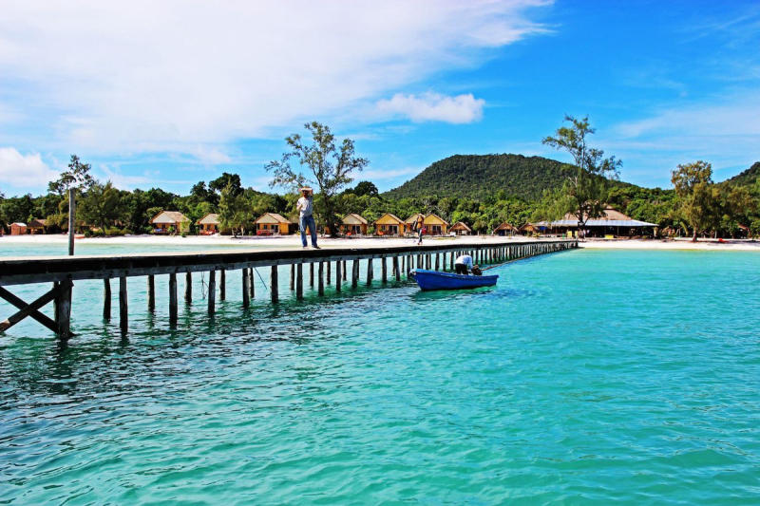
Lunch and dinner are not included
Overnight at selected hotel in Koh Rong.

DAY 08 KOH RONG – FREE & LEISURE (B)
Breakfast at hotel
Enjoy your own time at the beach! For any other activities like diving or snorkeling please check on spot with hotel you selected and this will be on your own account.

Lunch and dinner are not included
Overnight at selected hotel in Koh Rong.

DAY 09 KOH RONG – FREE & LEISURE (B)
Breakfast at hotel
Enjoy your own time at the beach! For any other activities like diving or snorkeling please check on spot with hotel you selected and this will be on your own account.
Lunch and dinner are not included
Overnight at selected hotel in Koh Rong.

DAY 10 KOH RONG – SIHANOUK VILLE - PHNOM PENH – DEPARTURE (B)
Breakfast at hotel
This morning, head back to Sihanoukville by boat.
Upon arrival at Sihanoukville boat pier head out to Phnom Penh.
Once you arrive at Phnom Penh, transfer to Phnom Penh’s International Airport for the taking the flight to your next destination.

END OF OUR SERVICES!!!

*PRICE PER PERSON IN USD
Validity: 01st Oct, 2025 - 31st Dec, 2026
Description | Adults (>12 yr old)
 | 1 | 2 | 3-6 | 7-10 | Single Supplement
 | Single Room | Twin/Double Shared Room
Category 3*
Category 4*
Category 5*

*INCLUSIVE OF ABOVE PROGRAM:
- Transfers as per the program
- 09 nights’ accommodation in Cambodia
- All entrance fee
- Boat trip to Kampung pluck
- Boat to Koh Rong
- Private A/C Vehicle
- English speaking guide
- Meal: breakfast at hotel
- 1 FOC in SGL for the group of 16 pax+
- Cold mineral water during the excursion

*EXCLUSIVE OF ABOVE PROGRAM:
- Visa fee to Cambodia
- International & Domestic air tickets
- All meals other than mentioned
- Tipping & Gratitude for driver & guide
- Personal expenses

*LIST OF HOTELS USE:
*Important Note: All hotels are subject to change to the similar ones
City | 3* Category | 4* category | 5* category
SIEMREAP | Pierre Hotel  DELUXE CITY VIEW  https://www.pierrehotelspa.com/ | Koulen Central Hotel  DELUXE  https://www.koulencentralhotel.com/ | J7 Angkor Hotel  CLASSIC  https://www.j7hotel.com/
PHNOMPENH | The ONRA Hotel  DELUXE  https://theonrahotel.com/ | Anik Palace Hotel  DELUXE URBAN  https://anik-palace-hotel.hotel-phnompenh.com/en/ | Palace Gate Hotel & Resort  ROYAL DELUXE https://palacegatepp.com/
KOHRONG | BeachWalk Koh Rong  Beach front Bungalow  https://beachwalkkohrong.com/ | You&Me Resort  DELUXE SEASIDE  https://www.youandmecambodia.com/ | The Royal Sand Koh Rong  Oceanview villa  https://www.theroyalsandskohrong.com/

